Homework Set 2 – Processors
Due Date: Friday, Nov 13, 2026

Problem 1: Short Questions. [30 points]

Part A: Identifying Hazards. [15 points]

For the following assembly code, find out all RAW data hazards that will cause stalls in a basic 5-stage pipelined RISC-V processor without any forwarding logic. For each hazard, answer 1) how many cycles the pipeline needs to stall if there is no forwarding, 2) how it can be resolved by using forwarding, and 3) how many cycles the pipeline still needs to stall after using forwarding. Fill in the table below. You may not use all rows in the table.

Assume the register file always supports half-cycle access. Branch condition and target are calculated in the ID stage. There is a branch predictor that always speculate not-taken.

1 addi s1, s0, -1
2 slli t1, s1, 2
3 add t1, a0, t1
4 lw t2, 0(t1)
5 slt t3, t2, s2
6 beq t3, zero, exit
7 addi s1, s1, -1

Lines | Register | Stall w/o fwd | Forwarding | Stall w/ fwd
1 and 2 | s1 | 2 | MEM to EX | 0

Part B: Dealing with Branches. [15 points]

Given a program with 15% instructions as conditional branches. When running a specific input dataset, 65% among these branches are actually taken. We compare different designs in a 12-stage pipeline to resolve control hazards. The pipeline needs to use the next PC to fetch instructions in its 1st stage.

For non-branch instructions, the next PC is resolved at its 1st stage, i.e., back-to-back execution. For branch instructions, the correct PC can be used to fetch an instruction in the next cycle after both the branch target and branch direction are resolved. If prediction is used, assume misprediction does not introduce any extra stalls to flush and restart the pipeline.

- Design 1: resolve branch direction and target in the 10th stage, and stall if needed;
- Design 2: resolve branch direction and target in the 4th stage, and stall if needed;
- Design 3: always predict not taken, and resolve actual branch direction and target in the 4th stage;
- Design 4: always predict taken, and resolve branch target in the 4th stage, but resolve branch direction in the 10th stage;
- Design 5: always predict taken, and resolve branch target in the 4th stage, but resolve branch direction in the 10th stage. Also use a branch target buffer (BTB) to predict branch target in the 1st stage, with 40% accuracy if predicted to be taken. Usually BTB does not store the untaken target (PC + 4) to save storage.

In each case, calculate the CPI penalty due to branches, i.e., average stalls due to branches divided by number of all instructions.

Problem 2: ISA vs. Hardware, More or Less? [20 points]

The instruction set architecture (ISA) is a specification of a certain processor architecture, while the microarchitecture of the hardware processor is an implementation of this specification. A more expressive ISA could potentially reduce the number of instructions in a program, but may complicate the hardware design and result in longer latency and higher power/area.

Part A: Displacement addressing. [10 points]

Consider the following idea to further simplify RISC-V ISA. Let’s remove displacement addressing mode, i.e., the ability to specify an offset for memory access instructions. Specifically, all load-store instructions with nonzero offsets would become pseudo-instructions and would be implemented using two instructions. For example:

addi t0, t1, 104 # calculate the offset separately
lw t0, t0 # new way of doing lw t0, 104(t1)

1. [6 points] What changes would you make to the datapath and control if this simplified architecture were to be used? Use the single-cycle processor implementation in the lecture as an example to explain. Explicitly show (in words or in diagram) how to change the connections between units.

2. [4 points] Give out two possible reasons for why the clock frequency of the single-cycle implementation could improve with the above changes.

Part B: Swap. [10 points]

A common operation in software is to swap the values of two variables. RISC-V chooses to simplify the structure of its instructions, so it does not have a swap instruction directly, and needs to decompose such complex instruction into multiple simpler ones.

1. [5 points] Show how you can implement the instruction “swap rd, rt”, which swaps the contents of two different registers rd and rt, using standard RISC-V instructions. Partial points are given if you use irrelevant registers. Use as few instructions as you can. Try not to use any other registers, but if you have to, you should assume they may contain useful values that will be used later.

2. [5 points] Consider a single-cycle RISC-V processor. If the implementation of this swap instruction in hardware will increase the clock cycle time by 12%, what percentage of swap operations in the instruction mix would recommend implementing it in hardware? What if the clock period would increase by 20%? Treat swap as one (pseudo-)instruction in the program when calculating instruction mix percentage.

Problem 3: Single-Cycle Processor. [25 points]

Part A: What Is It Now. [16 points]

Show all the necessary modifications in datapath and control to support each of the following instructions in the single-cycle RISC-V processor discussed in lecture. Please either describe in words, or show in each separate figure below, all necessary modifications needed in the datapath and control to support these instructions in the single-cycle RISC-V processor discussed in lecture.

1. [8 points] jal rd, offset

Note: jal stores pc+4 in rd and increases pc by offset. Its encoding is shown below.

Rearranged offset | rd | jal
31:12 | 11:7 | 6:0

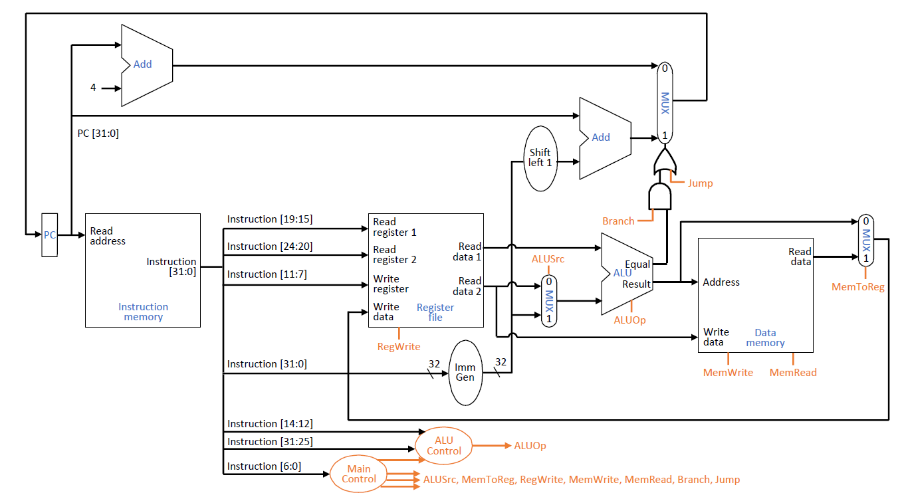

Explanation of datapath and control changes:

2. [8 points] lui rd, immediate

Note: lui puts immediate in the upper 20 bits in rd, and 0 for the lower 12 bits. Its encoding is shown below.

Immediate | rd | lui
31:12 | 11:7 | 6:0

Explanation of datapath and control changes:

Part B: What Will Be Next. [9 points]

It happens quite often that we wish to index through and access each element of an array. Absent from RISC-V, but present in other assembly languages/instruction sets are load/store commands which also increment the indexing register.
For example, lwinc rd, offset(rs1) would perform the normal load, and also subsequently increment rs1 by 4. In this problem you can assume rd and rs1 are never the same register.

Please either describe in words, or show in the figure below, all necessary modifications needed in the datapath and control to support this instruction in the single-cycle RISC-V processor discussed in lecture.

offset | rs1 | func | rd | lwinc
31:20 | 19:15 | 14:12 | 11:7 | 6:0

Problem 4: Pipelining [25 points]

Consider the final design of the 5-stage pipeline discussed in lecture, with the following details:
- All instructions read their source operands in the ID stage and write-back their destination in the WB stage.
- ALU instructions calculate their results in the EX stage.
- Load/store instructions calculate their address in the EX stage and then perform the actual memory access in the MEM stage.
- Branch and jump instructions complete their execution in the ID stage. In addition, the processor uses a branch predictor that assumes always-not-taken.
- The pipeline supports full forwarding, whenever forwarding is possible.

The following code is so-called SAXPY, frequently used in linear algebra:

for (i=0; i<100; i++) Y[i] = 8 * X[i] + Y[i];

Assume that registers s1 and s2 contain addresses of the first elements of the arrays X and Y, respectively. Register s3 contains the loop index i (initialized to 0). Finally, assume that s9 has been preloaded with the constant value 100. All arrays store 32-bit integer numbers. The assembly code for this loop is:

loop:
1 lw t0, 0(s1) # load X[i]
2 slli t1, t0, 3 # calculate 8*X[i]
3 lw t2, 0(s2) # load Y[i]
4 add t3, t2, t1 # calculate 8*X[i]+Y[i]
5 sw t3, 0(s2) # store Y[i]
6 addi s1, s1, 4 # increment X index
7 addi s2, s2, 4 # increment Y index
8 addi s3, s3, 1 # increment i
9 bne s3, s9, loop # loop
finish:
1. [12 points] Fill in the table at the end of this problem, to show how one typical iteration of the loop executes. A typical iteration means one during the stable phase of the loop, not at the beginning or the end. Use “–” to show cycles during which an instruction is stalled. For instance, if an instruction stalls in the ID stage for one cycle, the diagram should show “IF ID – EX MEM WB” for that instruction. When branch misprediction happens, you can also use “–” to denote the cycles that execute mispredicted instructions. You may need more columns than currently shown.

How many cycles are needed for one typical iteration of the loop? Report all cycles from the IF stage of the first instruction to the WB stage of the last instruction (both included).

Tip: the key to filling in the table correctly is to identify when data can be forwarded between dependent instructions and when stalls are needed for correct execution. Start by identifying RAW dependencies between instructions. Then carefully track when the register value in question is actually produced and when it needs to be consumed in the pipeline.

2. [4 points] Use the last two rows in the same table, to show how the next iteration execute. You only need to show the first two instructions in the table, since the rest just repeat the same patterns as the previous iteration.

Assume the loop executes many iterations. What is the average CPI of the SAXPY program?

3. [9 points] Rewrite the assembly code of the loop in order to minimize the number of cycles needed for a single iteration of the loop. Without filling in the table below, can you say how many cycles an iteration of the optimized loop will take (from the IF stage of the first instruction to the WB stage of the last instruction)? Hint: you need to reorder dependent instructions to avoid pipeline stalls.

 | Cycle
 | 0 | 1 | 2 | 3 | 4 | 5 | 6 | 7 | 8 | 9 | 10 | 11 | 12 | 13 | 14 | 15 | 16 | 17 | 18 | 19 | 20
lw t0, 0(s1) | IF | ID | EX | MEM | WB
slli t1, t0, 3
lw t2, 0(s2)
add t3, t2, t1
sw t3, 0(s2)
addi s1, s1, 4
addi s2, s2, 4
addi s3, s3, 1
bne s3, s9, loop

